# Comp 266 Unit 5 – Writing JavaScript: Program Design

***Recipes on Hand***

## Design Process for each Idea

### Design 1: Sign Up/Login Form

The main core of the JavaScript code for the sign up and login form is the error checking. The logic consists of a set of conditional statements that checks the forms if they contain valid text. A number of constant methods will be created for each error checks, such as checking if a field is blank or empty, or

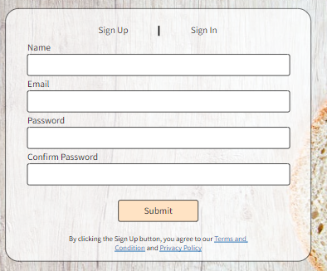

The form selected should be the form that is visible. There should be error checking for these forms, here are some examples:

Sign Up:

* Invalid email address
* Poor password complexity
* Confirm password does not match
* Email address already in use
* Empty forms

Sign In:

* Email or password incorrect
* Empty forms

Accounts should hold data about the profile and interactions made by the user on the site such as comments, likes, posts, etc.

This idea is the backbone of the webpage for users such as Donna Karen or Raymond Nodul who actively participates in the community side of the website. The sign up and log in feature allows such users to be individualized and make their own contributions towards recipes they have strong feelings about.

### Idea 2: Comments under Recipe page and posts under Discussions page

This feature would allow users to create comments to recipes that actually appear in the comments list. If no comments have been made, the list should be empty. There is a filter that can sort by date submitted, either ordered by oldest or newest. As well tying in the discussions page which should have a similar function. Posts or comments created should remain on the page after the page is refreshed. The post or comment itself should clearly outline the user that commented it, as well as the content that was submitted. If the user is not signed in or have not made an account, it will not allow any posts or comments to be made.

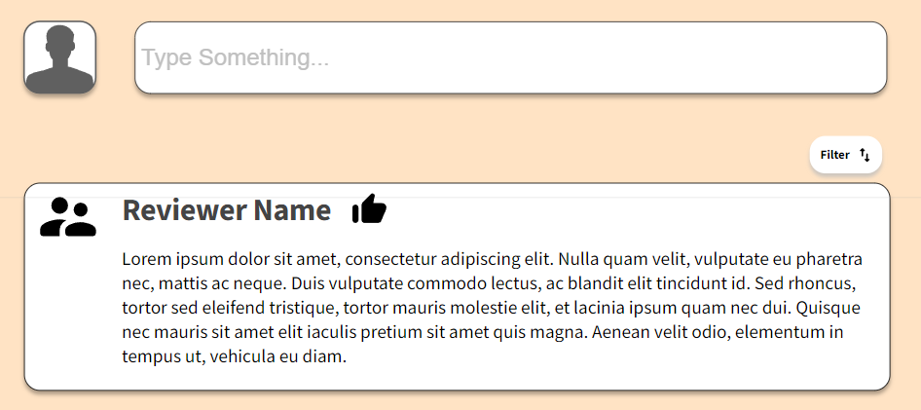

Raymond Nodul is a prime example for a persona and scenario where this function is necessary. In order to improve his skillset in the culinary arts, he must take on more and more challenging recipes, but he won’t be able to achieve that without his fellow cooks providing tips and comments on the recipe page. His active contribution and participation towards the community aspect of the recipe page will help improve his own skills as well as others around the world.

### Idea 3: Recipe Page Side Bar Functions

On the recipe page, there is a side bar with a heart symbol, Facebook symbol, print symbol and mail symbol. These are actions that the user can make in relation to the recipe on the page. The heart symbol is an interaction that can hold the number of people who liked the recipe, as well as allow the user to like the recipe itself. This can affect the popularity filter on the recipe list when sorted. The Facebook symbol can help the user to quickly share the recipe with their friends and family on Facebook. The intended functionality should open the Facebook page when pressed, and automatically create a template post that the user can easily share. The print button will open the page in a printable document for their easy access purposes. The mail button will open up their native email application to send a template email that includes the instructions from the recipe, the link to the recipe, and also a printable document so it can be sent to themselves or anyone they desire.

Donna Karen was an example where she actively gives ratings or likes on a recipe she has opinions on. She may find it easier to print the document to have the recipe by her side near the kitchen, and she definitely has families and friends that she would love to be able to share the recipe with, either via email or Facebook.